Thandai Juice Corner

Parvez Hossain Saurav

# Restaurant Concept

**Restaurant Name & URL**

Thandai Juice Corner

thandai.com

Healthy Organic Juice Delivery Service and daily subscription.

**Food & drink**

*Customization*

* Yummy Health
* Orange Juice
* Lemon Mint
* Rime Mango Juice
* Koromcha Juice
* Blackberry Juice
* Grape Juice
* Pineapple Juice
* Watermelon Juice
* Health Boost
* Jeera Pani
* Olive Juice
* Carrot Juice
* Papaya Juice
* Special
* Greeny Myny
* Desi Beet

**Location**

Rajlaxmi Complex, Sector #3, Uttara, Dhaka

Delivery Radius: Dhaka City

**Main target audience**

* Health conscious
* Juice Lover
* Fitness Geeks
* Teens
* Elderly People

**Cost**

*$ - Affordable*

**Elevator pitch**

*Healthy Yummy organic juice at your door step. Feeling hot in summerdays or need a health boost Thandai is here to meet your everyday juicy need.*

# Strategy

## Target Audience

The website/app will focus on the following target audiences:

**Roles** (groups of people with similar goals)

* *Health Worker*
* *Juice lover looking for organic juice*
* *Health concious Adult citizens*
* *Young Fitness Geeks.*
* *Young youthful students*

**Demographics**

* **Gender** - Male and Female
* **Education** -Moderate to High
* **Occupations** - Health Workers, Students, Fitness Fanatic
* **Age** - 18-65
* **Location** - Dhaka ( Mainly Dhanmondi, Azimpur, Zhigatola, Mohammadpur, and Shamoly.)

**Psychographics** (personality, values, attitudes, interests, lifestyles)

*Think of at least 5 details among the categories below.*

* **Personality & Attitudes:** 
  + Health Concious
  + Youthful
  + Fitness Fanatic
* **Values:** 
  + Religious ( No Alcohol)
  + Health Safty
* **Lifestyles:**
  + Routine Lifestyle
  + Active
  + Family
  + Atheletic & Energetic

# 

# Strategy

## 1User Personas (optional)

**Arfan Khan (17) – Fitness Guy**

* 17 year old college student
* Play football in college
* Fitness fanatic
* Don’t drink alcohol



**Selin Akhter (28) – Health Worker**

* Work at Anisa Health Clinic
* Married for 3 years
* Mother of one child
* Serious about freash and nutreint food for her family.



**Junayed Hossen (48) – Director of NSLA Corp.**

* 48 year old busy director
* Married for 15 years
* Father of 2 children
* Has many health issue
* Have follow a strict healthy routine

# 

# Strategy

## User Needs

The website needs to enable the user to:

* Find out if the delivery is available in the area
* Order Juice online
* Activate Subscription of package for daily Organic Juice delivery
* View and choose from different type of juice
* Maintain different subscriptions
* Find out if the juice corner is open

## Client Needs

The website needs to enable the client to:

* Deliver juice online
* Providing daily subscription base service
* Provide a system for order customization
* Communicate reliabily
* Advertising different type of juice availibility

# Outline of Scope

## Content Requirements

Content (text, images, video) that the user will need.   
*“The user will be looking for…”*

* Location
* Openning Time
* Drink Options
* Drink Images
* Drink Prices
* Drink Ingredient
* About Us
* Subscription Packages
* Subscription Process
* Contact
* FAQ
* Customer Review

## 

## Functionality Requirements

Systems that will allow the user accomplish tasks.

*“The user will be able to…”*

* Place Custom Order
* Check Availability
* Local Payment methods
* Track Order
* Create Account
* Log in
* Juice Delivery Subscription
  + Delivery Interval
  + Delivery Selection
  + Bill Calculator
* Live Chat Support
* Large Order Booking

# Artboard – 2Sitemap

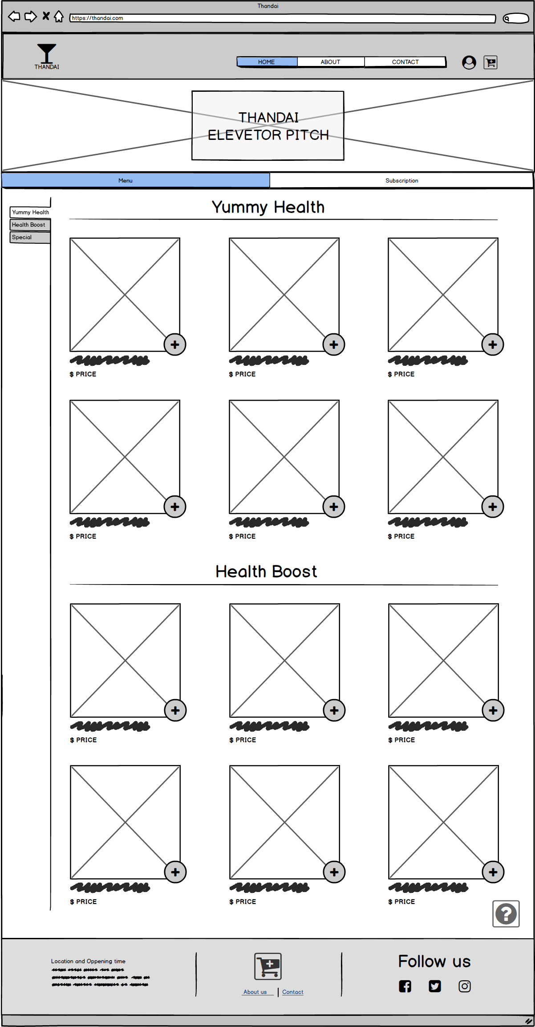Desktop Home

Custom Menu

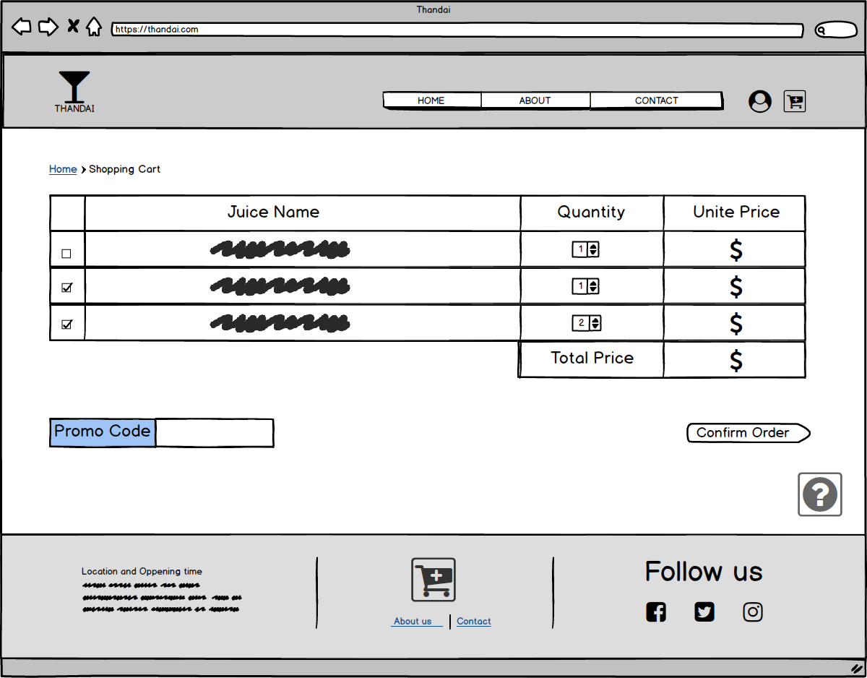Shopping Cart

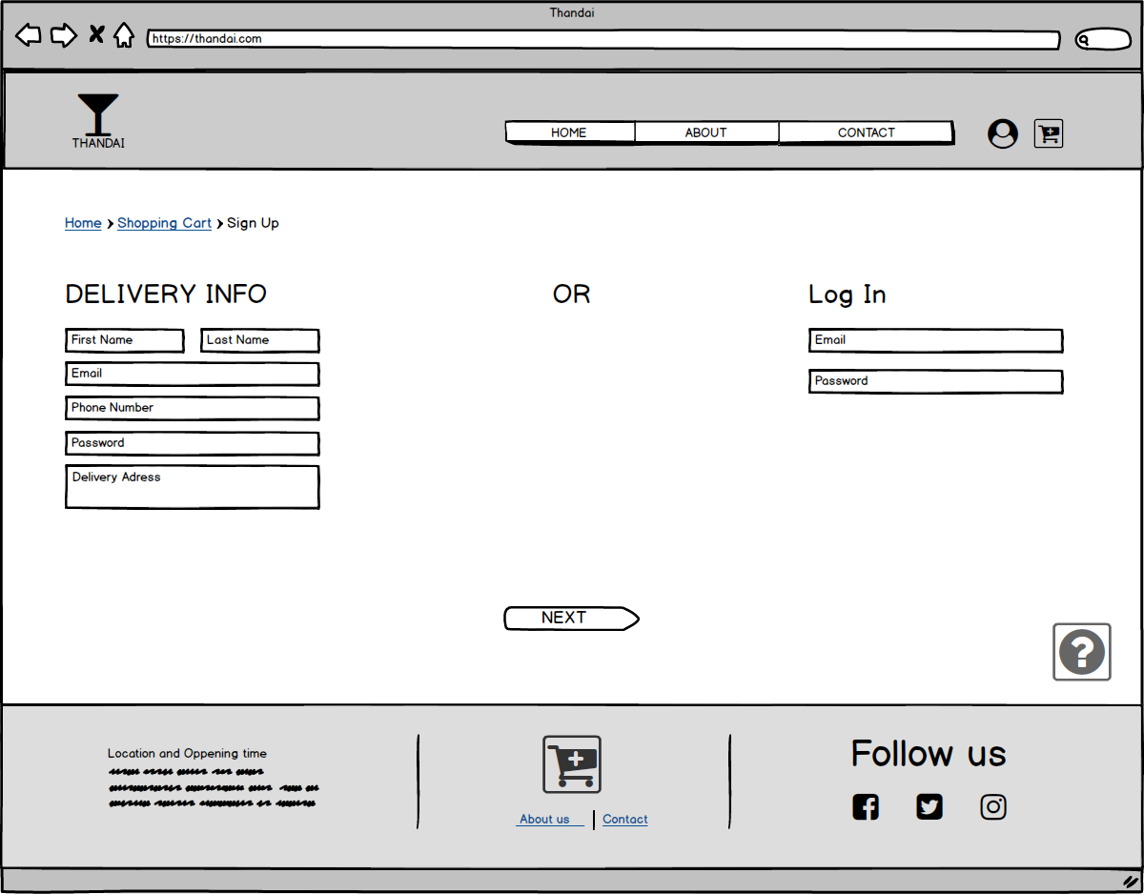Sign Up

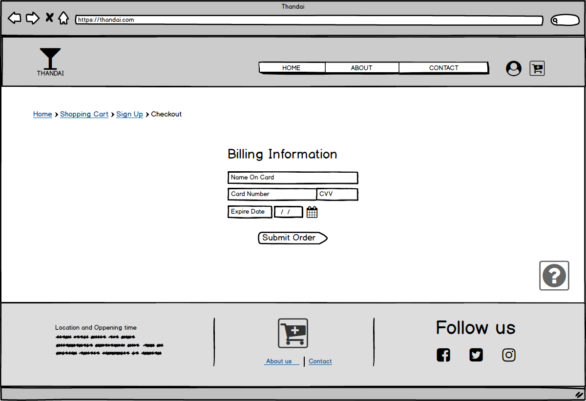CheckOut

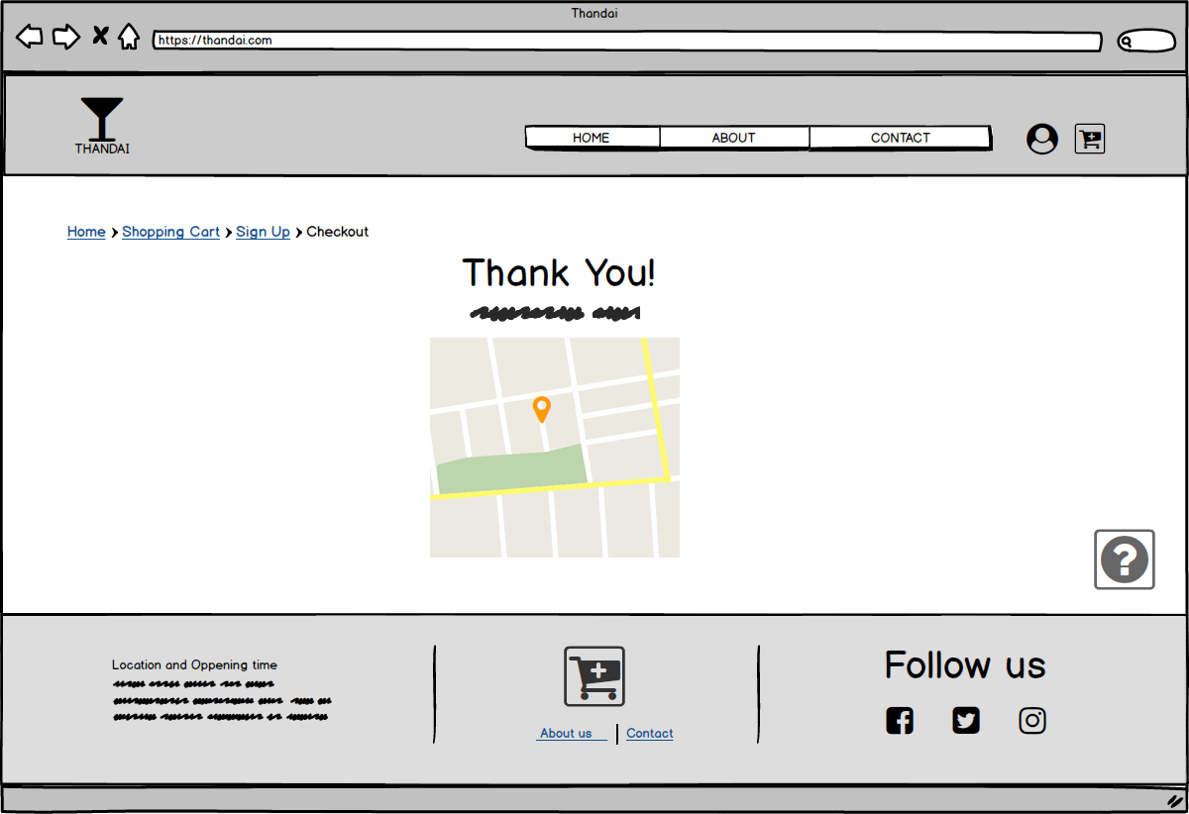Track Order

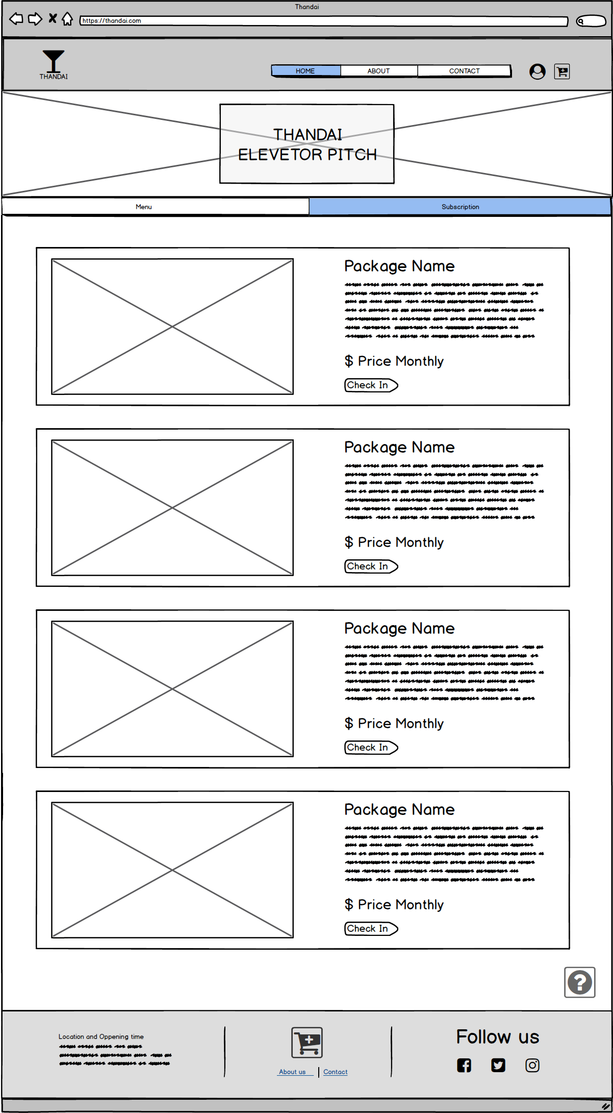Desktop Home

Daily Juice Delivery

Subscription

Sign Up

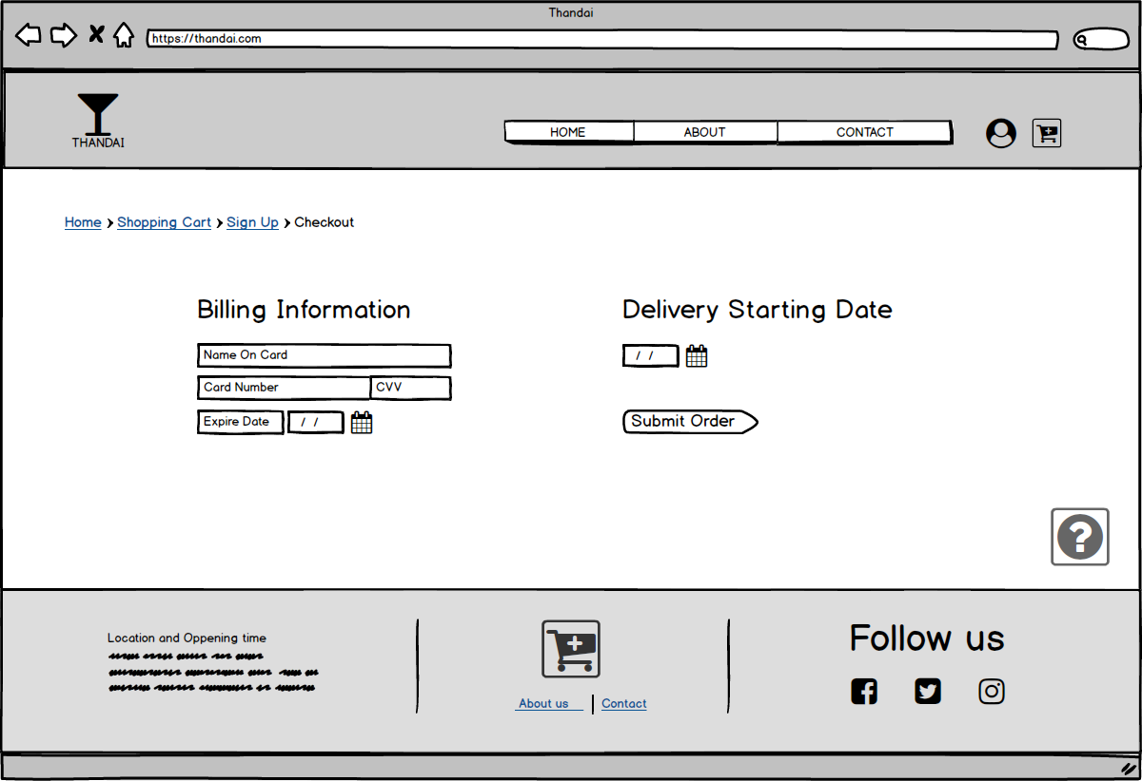Subscription Checkout

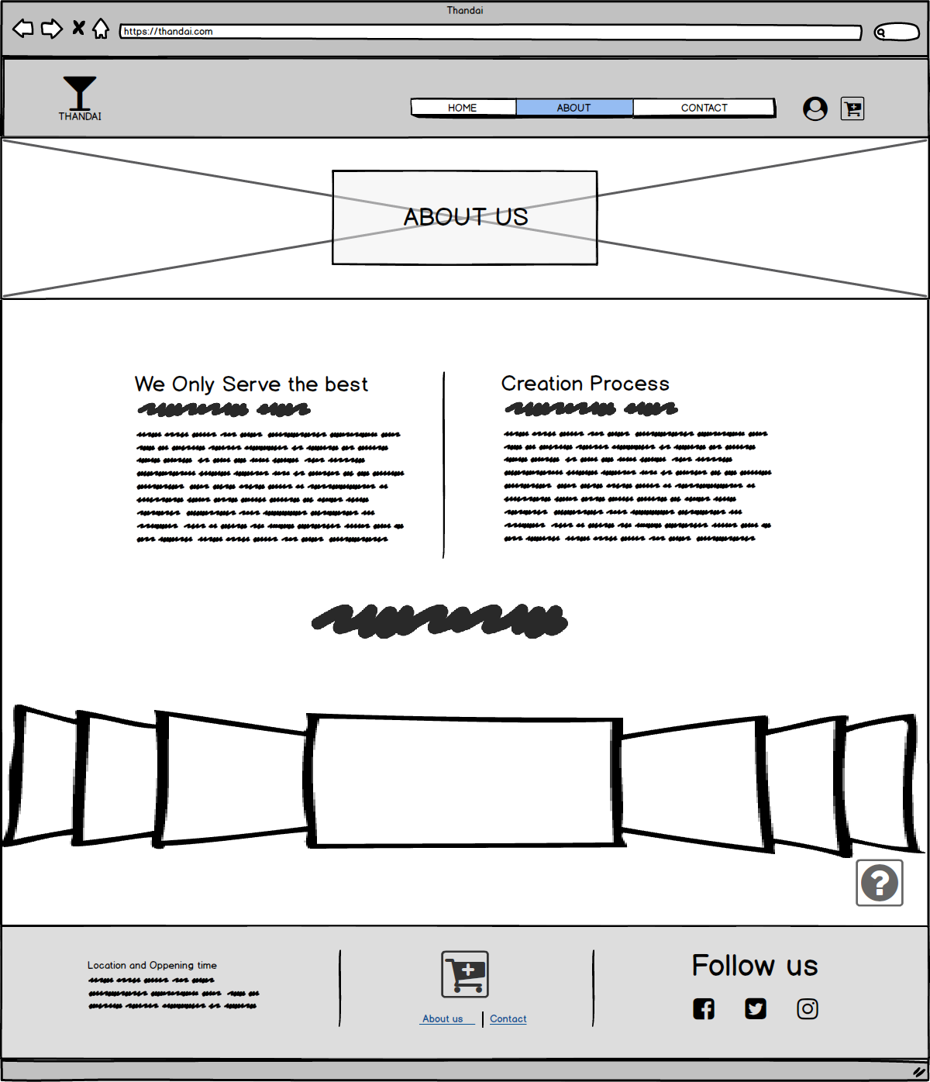About

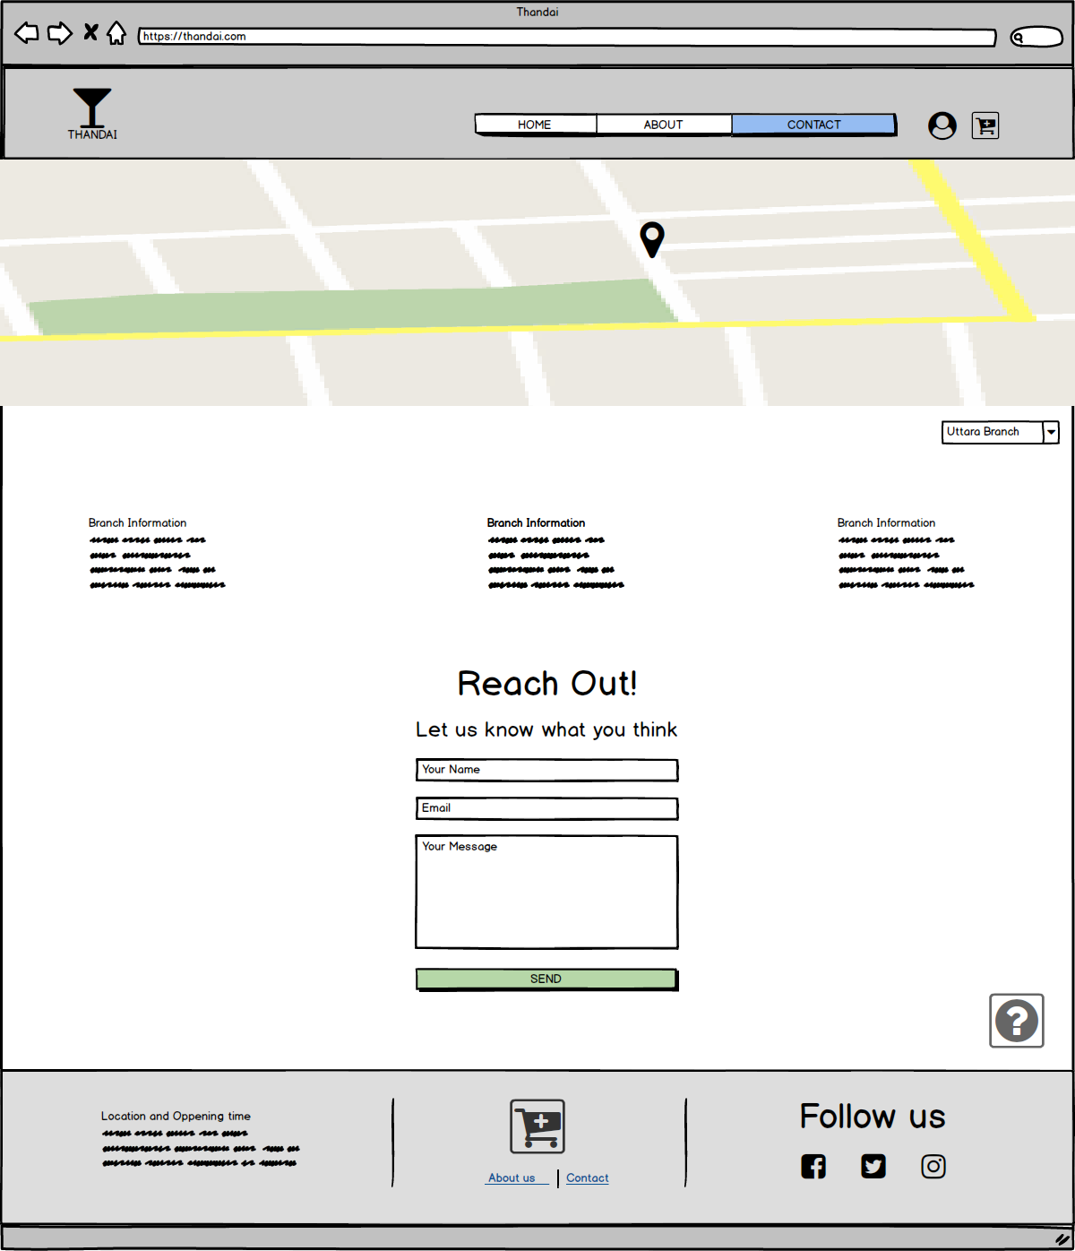Contact Us

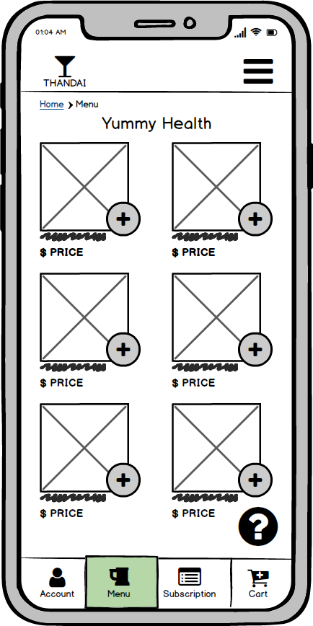Mobile Home

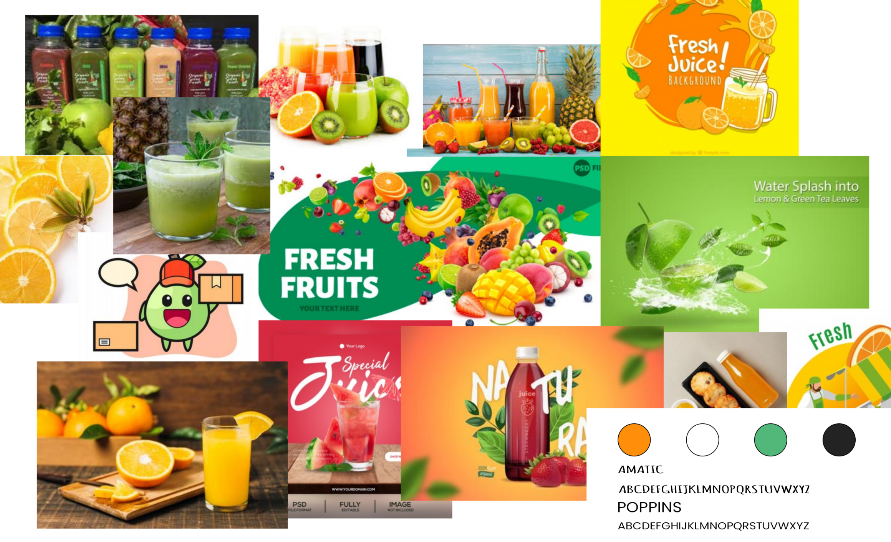MoodBoard

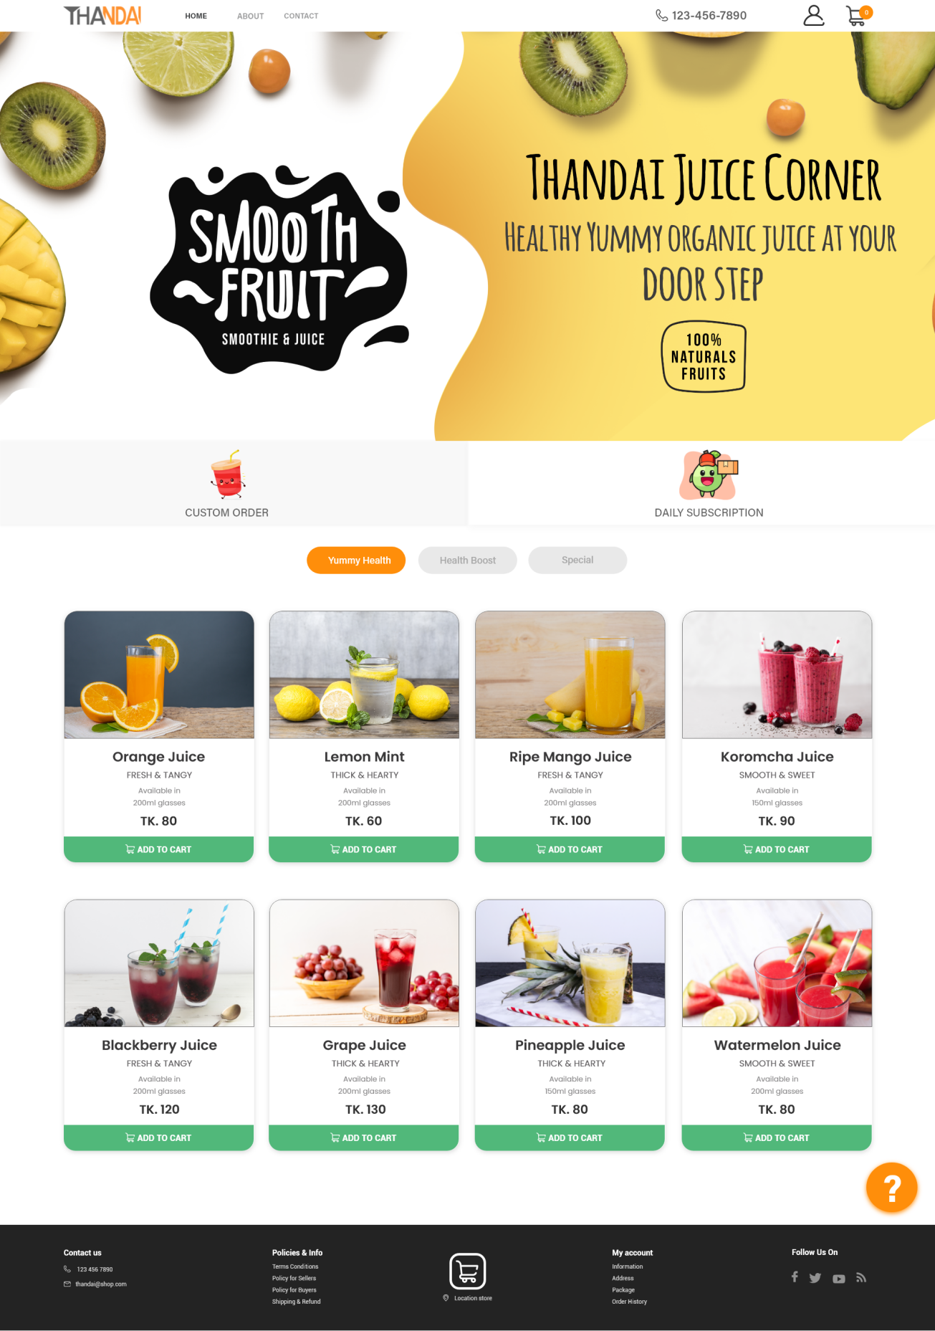Web Home Mockup

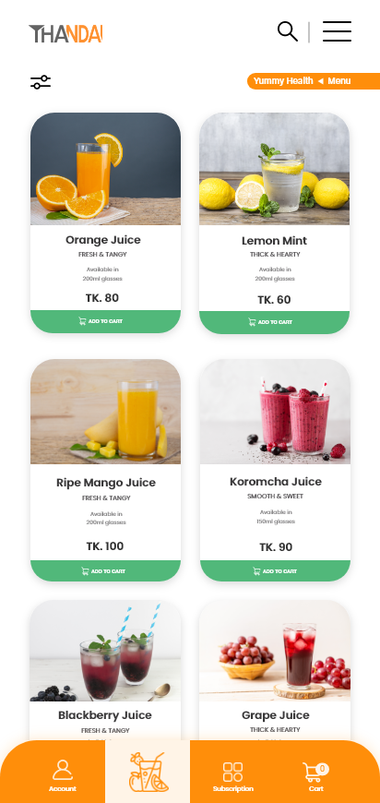Mobile Home Mockup

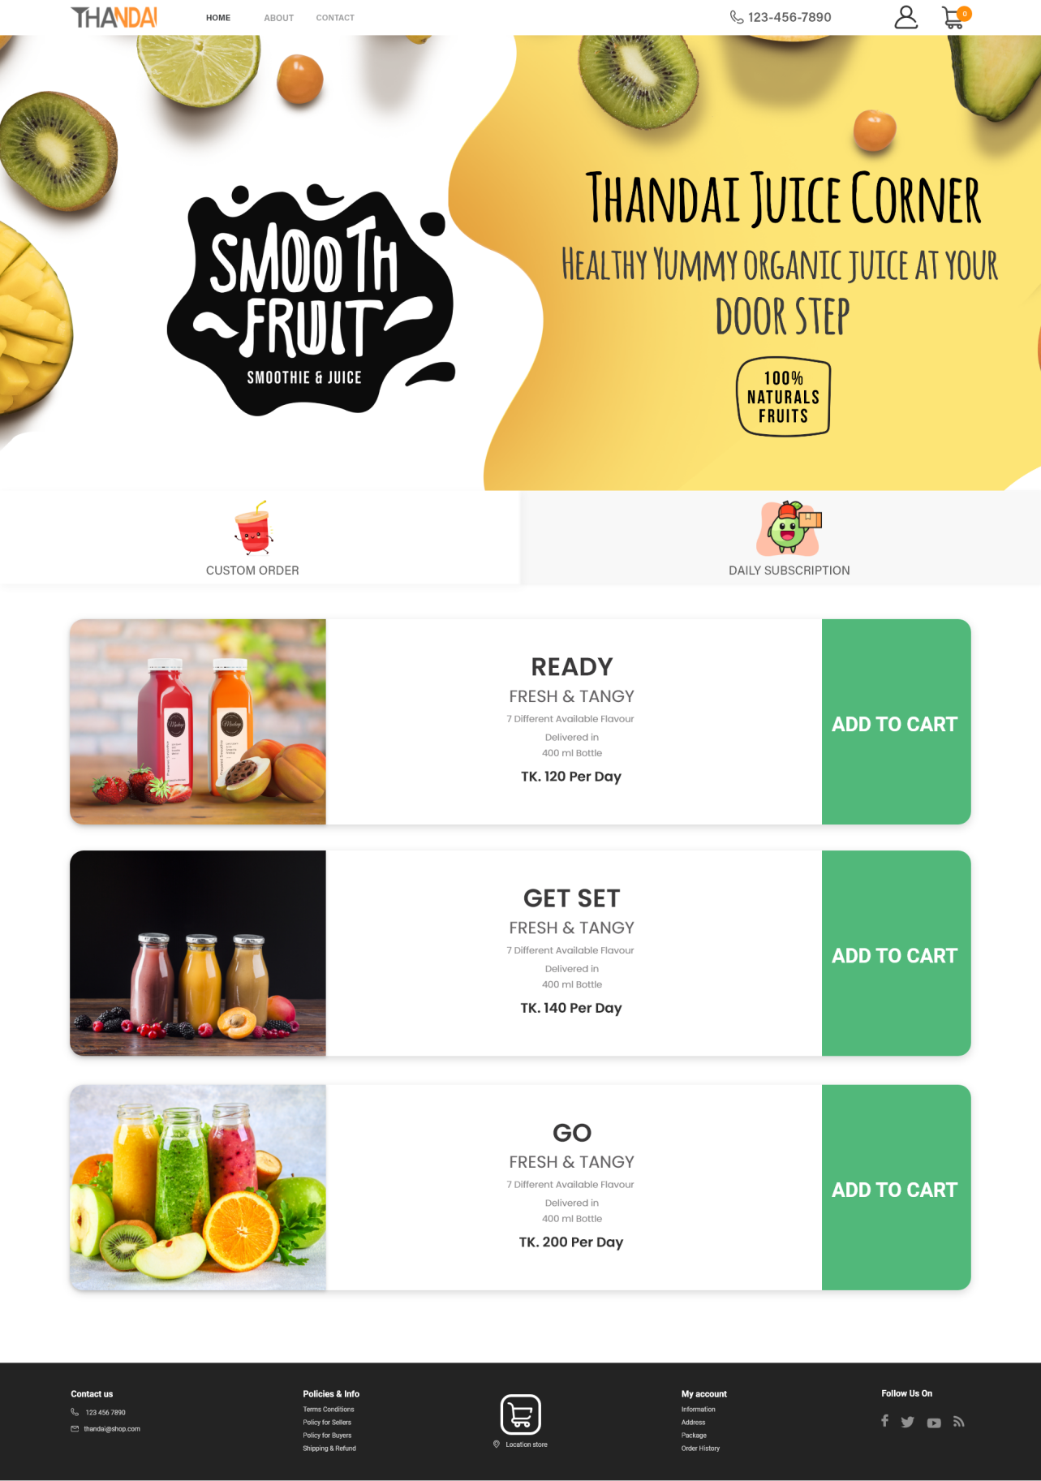Daily Home

Subscription

Packages

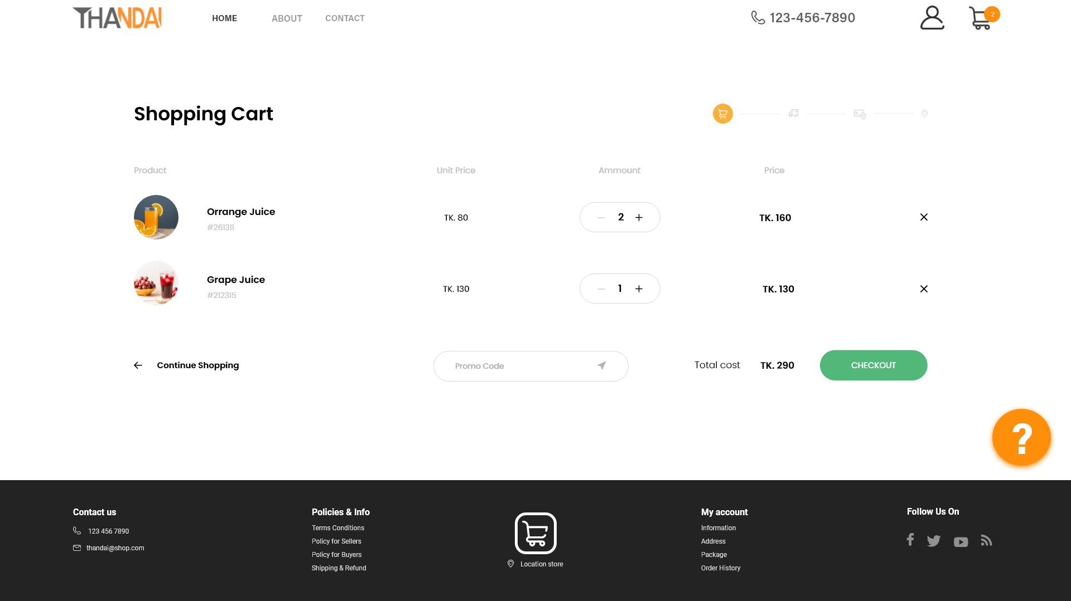Shopping Cart

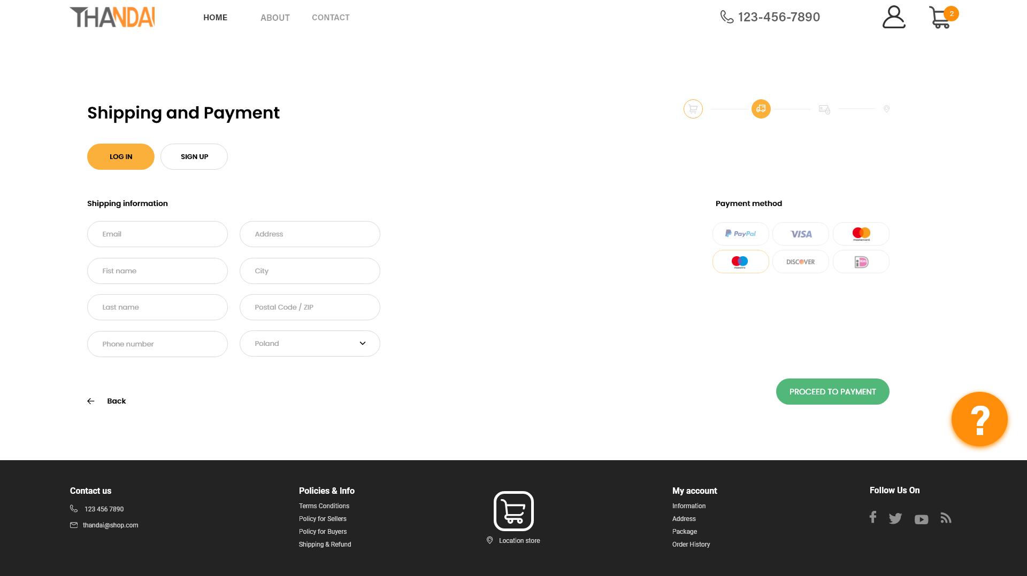Shipping Information

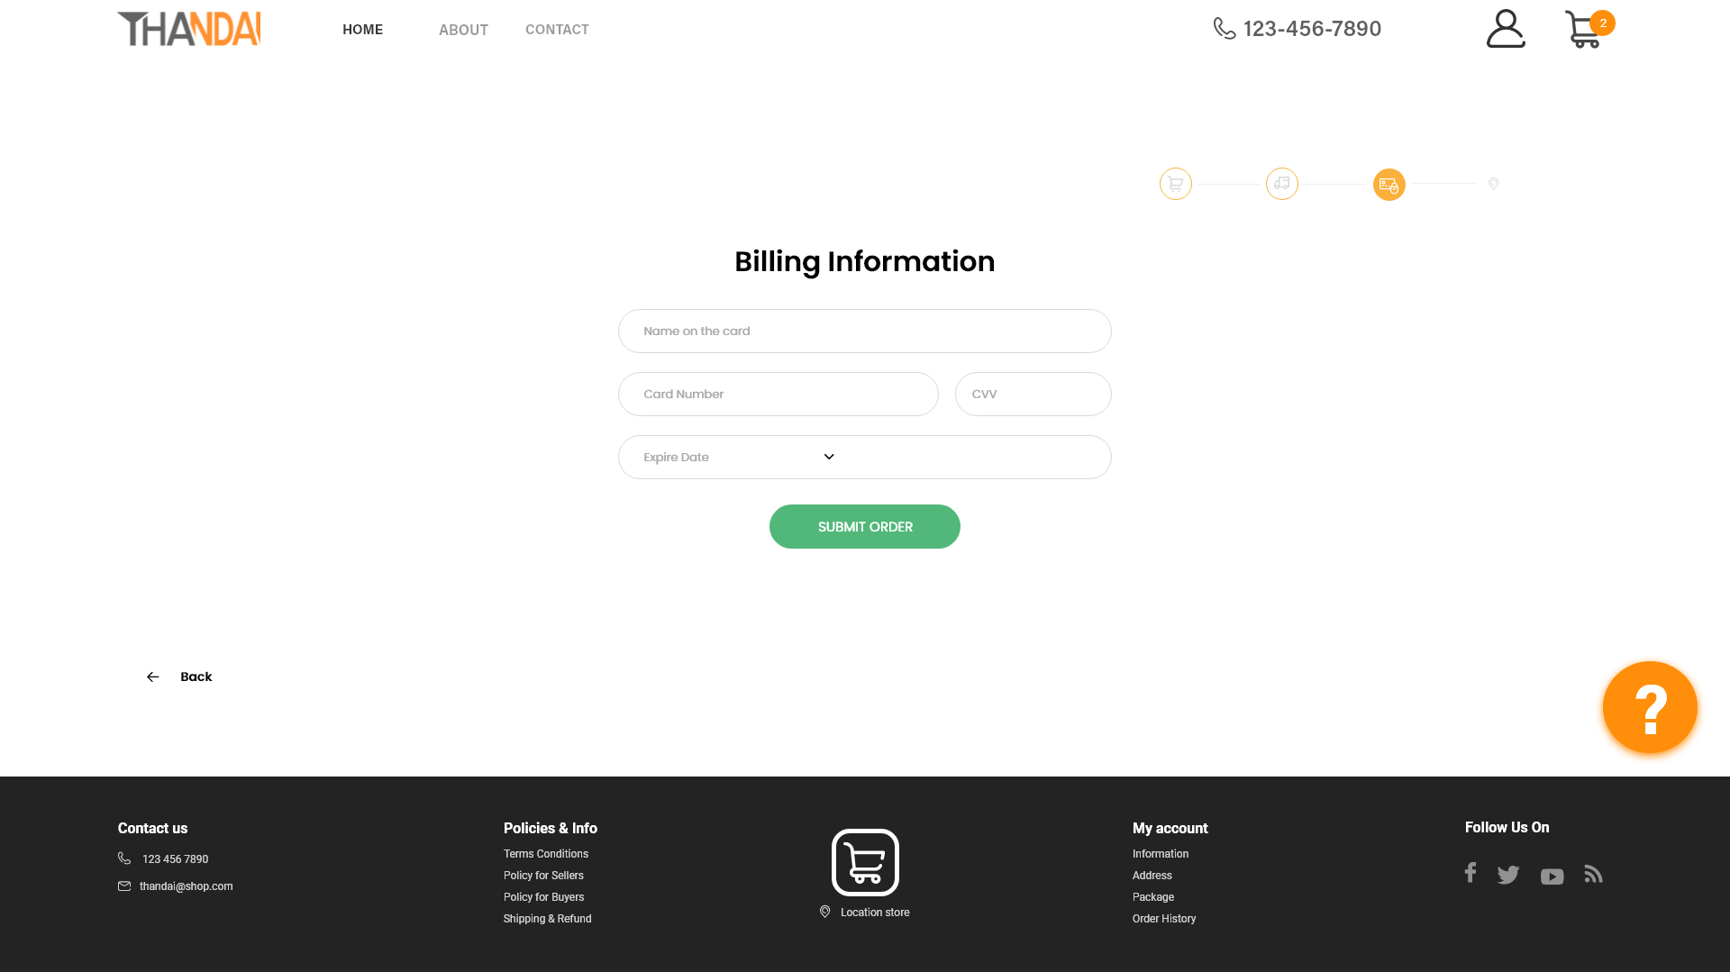Billing Information

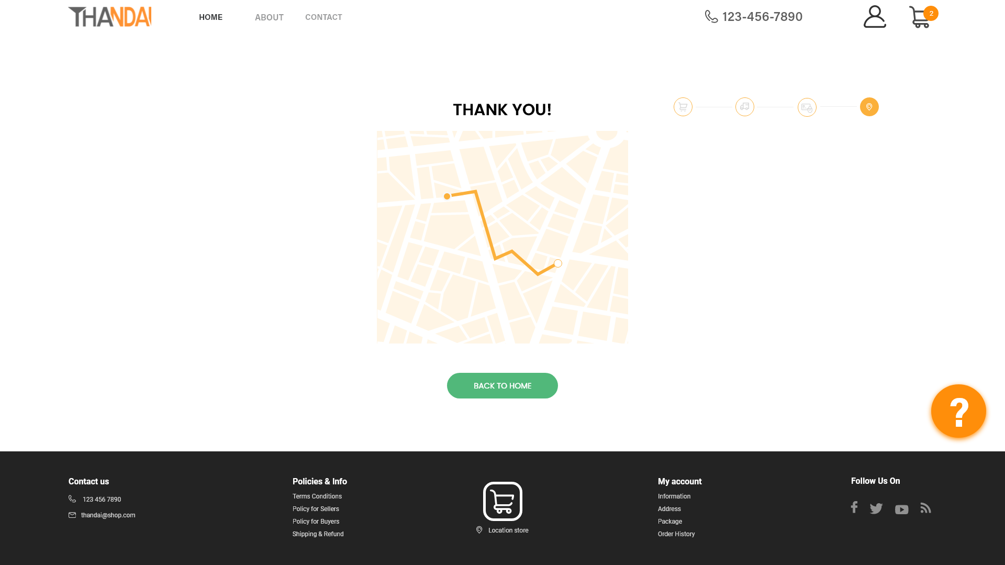Tracking Order

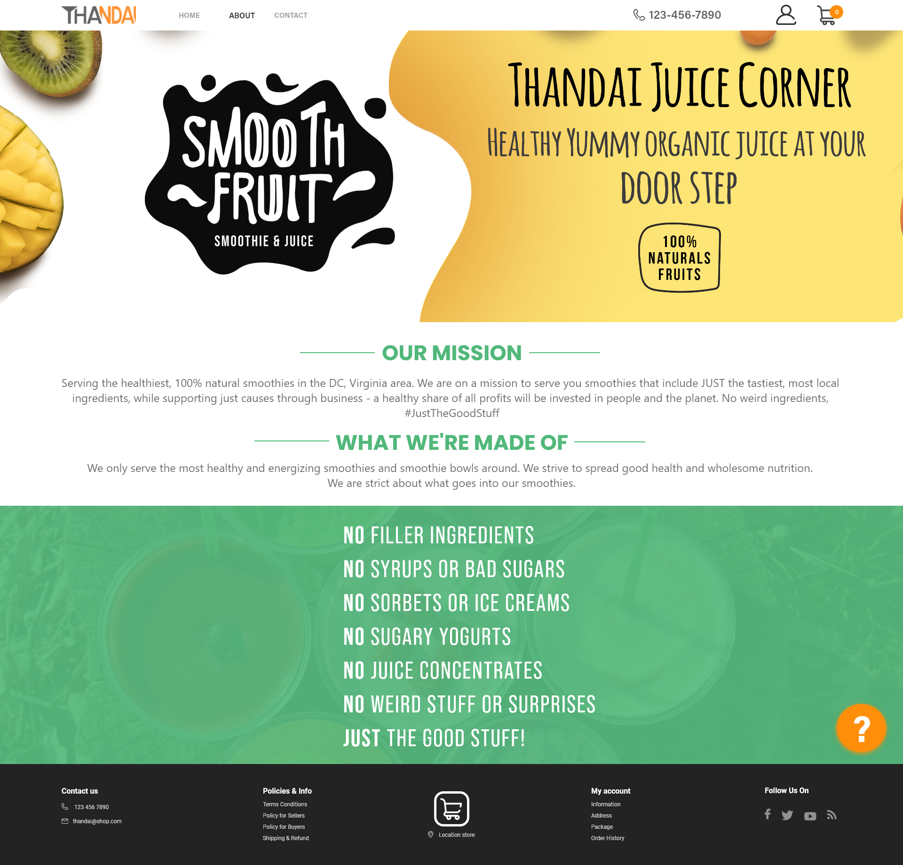About  
Page

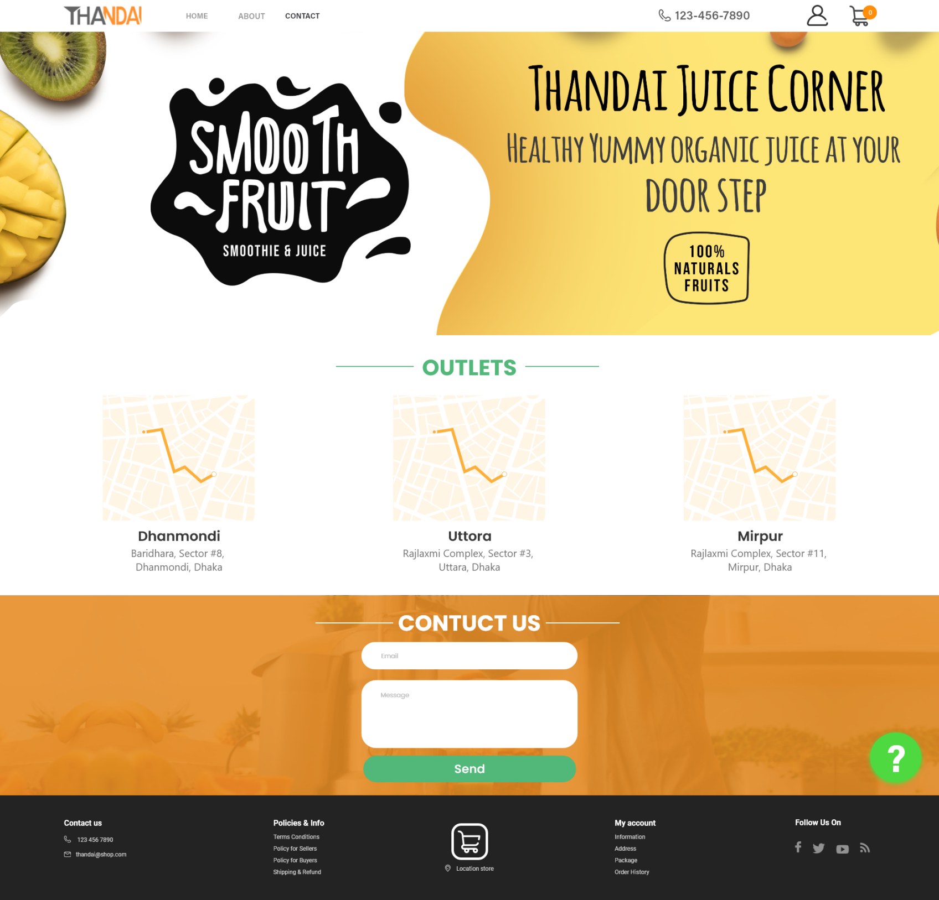Contact

Page